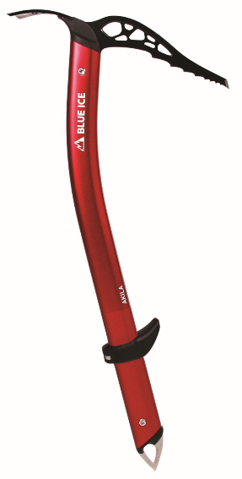

This declaration of conformity is issued by the manufacturer:

Blue Ice Europe
336 route du Nant Jorland
74310 Les Houches
FRANCE

That declares under its sole responsibility that the following product:

Name: Akila (with adze)

Reference: 100167- XXX-YYY (XXX = color code; YYY = size code from 40cm to 70 cm)

Is conform to the requirements of the European regulation (EU) 2016/425
According to: EN 13089:2011 + A1:2015 and UIAA 152: 2018 (to the exception of §2.2)

The notified body that performed the EU type examination module B and issued the EU type examination certificate is:

Apave Exploitation France SAS (n°0082)
6 Rue du Général Audran -92412 COURBEVOIE cedex – France

EU type certificate n°: 0082/1332/136/04/21/0270

This product is subject to the conformity assessment procedure to type base on internal production control plus supervised product checks at random intervals (Module C2), under the surveillance of the notified body APAVE SUDEUROPE (n°0082)

Les Houches, France, 12/21/2022

Maxime CLEMENT
Quality Manager
